- Lower inflation data in the UK and US caused an abrupt turnaround in market pricing this week. Evidence to justify the change in domestic sentiment was thin – the UK's downside surprise for inflation was focused on volatile categories and should reverse next month. But it seems to have encouraged markets to focus on the Monetary Policy Committee's recent more dovish messaging.
- Alan Taylor, one of three MPC members to vote for back-to-back rate cuts in December, gave his maiden speech this week. He was far more candid than most MPC members tend to be, with his illustrative paths for Bank Rate under the Bank of England's three inflation scenarios all showing more rate cuts this year than market pricing had implied on Tuesday.
After last week's turmoil, it's been a much better week in financial markets. Though last week's sell-off continued at the start of the week, by market close on Thursday, 10-year gilt yields were back at 4.68% – the lowest level since January 7 and down 21bps from Tuesday's peak.
In seeking to explain the sharp rise in yields, we had argued it was mainly a story of international (largely US) influences and higher expectations for Bank Rate. The importance of both factors could also be seen in the drop in yields over the past couple of days. Wednesday's fall was triggered by UK inflation coming in softer than expected, with good news on US inflation later in the day adding to the downward momentum. A below-consensus outturn for UK GDP triggered a further, more modest fall in yields across the curve.
But just as evidence to justify the initial rise in yields was thin, there was little in the inflation data to warrant such a big pullback. December's outturn for CPI of 2.5% was 0.1ppt below consensus. And though the downside surprise was due to lower services inflation – a key piece of the monetary policy jigsaw in recent years – that was almost entirely driven by two volatile sectors: air fares and accommodation services. The Office for National Statistics said that the choice of dates for monitoring prices – the return date for European flights was Christmas Eve and for long-haul it was New Year's Eve – was likely to be the cause of the low reading for air fares (Chart 1).
Chart 1: December's downside surprise for inflation was largely due to erratic categories
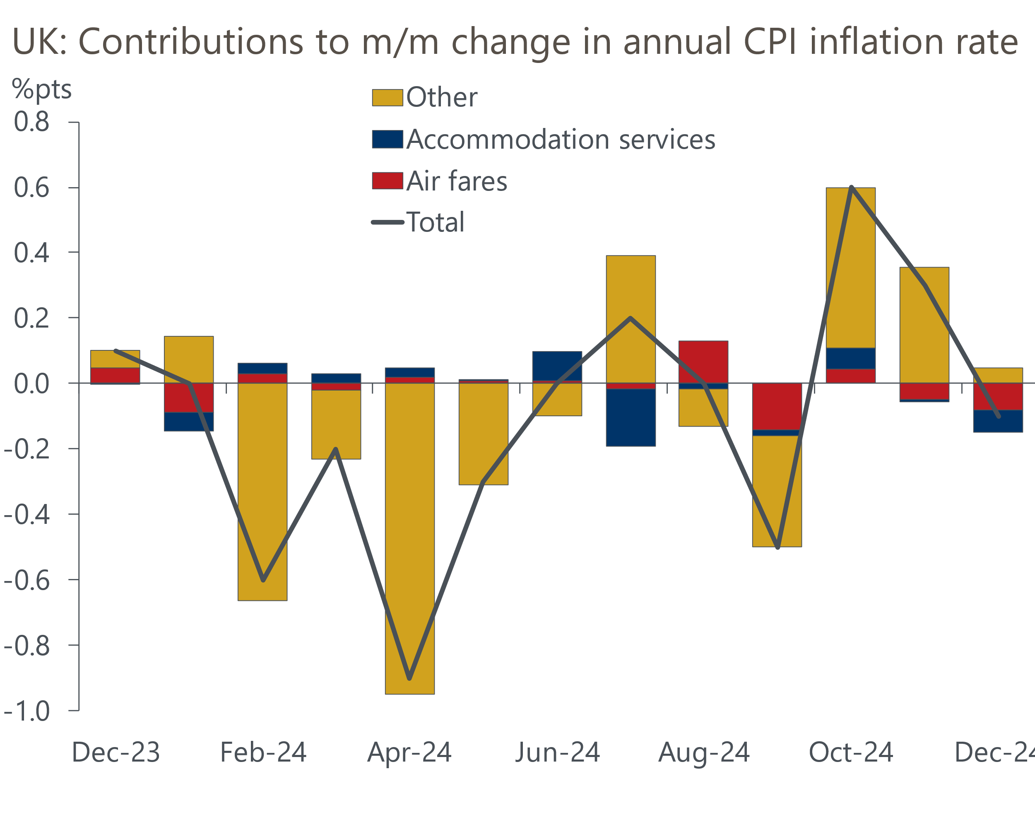
Source: Oxford Economics calculations using data from Haver Analytics

The downward pressure from air fares and accommodation services will likely unwind in next month's release, and we expect this to mark the start of an upward trajectory for inflation that will last until early autumn. Indeed, in our view, the near-term inflation outlook has deteriorated since last month because of the recent surge in wholesale gas prices, and we now expect the CPI measure to average 3% this year.
But while the inflation release offered little in the way of genuinely dovish news, it did seem to better focus markets on what the Monetary Policy Committee has said is important to them in setting Bank Rate. On Tuesday, market pricing implied just 34bps of rate cuts by the end of 2025. Yet the minutes of December's meeting had been clear that all except Catherine Mann were in favour of gradually loosening policy. And after a couple of years of focusing only on inflation, the MPC now acknowledged the trade-off between inflation persistence and greater weakness in output and employment.
November's GDP release added to the concerns around the growth outlook. Though output rose by 0.1% m/m, this was below our expectations and those of the consensus, and it merely reversed October's fall. Absent historical revisions, it now seems likely that activity was flat for a second successive quarter in Q4. Indeed, if December's fall in retail sales is representative of the wider consumer sector, the risks are skewed towards there having been a small q/q fall in GDP in Q4.
While we still think H2 2024 is more likely to prove a blip rather than the start of a sustained slowdown, soft output data are consistent with the MPC continuing to gradually cut Bank Rate. That point was reinforced by external MPC member Alan Taylor in his maiden speech this week. Taylor was far more candid about the monetary policy outlook than his colleagues have tended to be, giving his probabilities for the BoE's three inflation scenarios, and offering illustrative paths for Bank Rate for each case. Taylor also advanced an additional scenario where output continues to weaken, disinflation accelerates, and interest rates fall below their neutral level for a time, making clear his dovish bias.
Taylor stressed that the interest rate paths were his own interpretation. But the indicative paths he sketched out didn't look unreasonable and it was notable that for all of the MPC's inflation scenarios, including the one where inflation proves highly persistent, Bank Rate would be lower at the end of 2025 than market pricing had implied on Tuesday (Chart 2). Indeed, by the end of 2026, the gap between market pricing and Taylor's highest scenario for Bank Rate widened to around 50bps.
Chart 2: Taylor's indicative Bank Rate paths were all lower than market pricing at end-2025
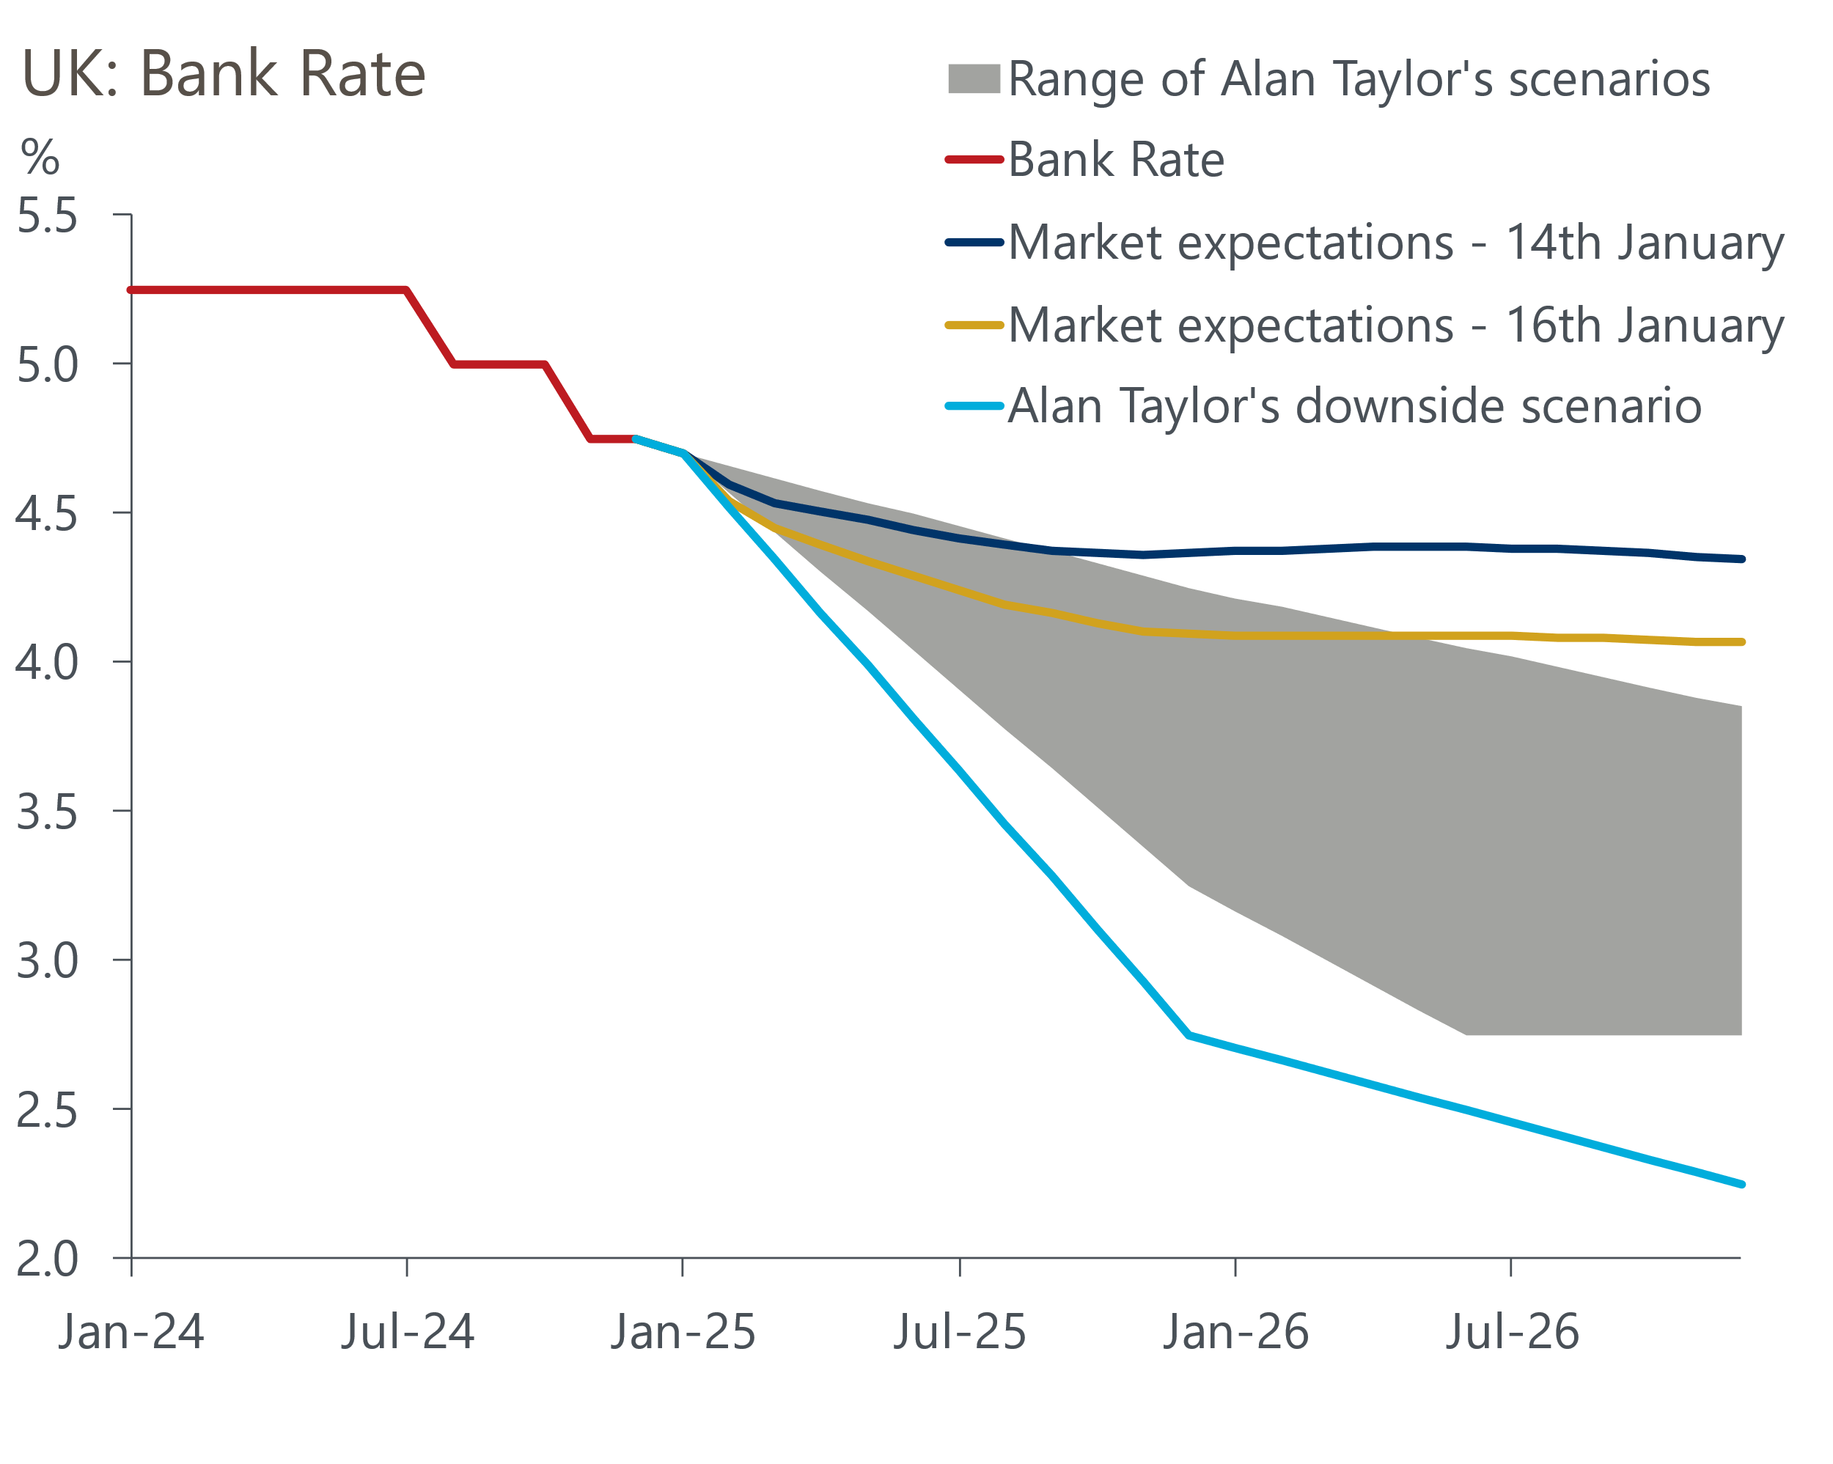
Sources: Oxford Economics, Haver Analytics, Bank of England
By market close on Thursday, markets had repriced and were now looking for 60bps of rate cuts this year. We still think this is on the low side – we continue to forecast 100bps of cuts, in line with Taylor's path for the MPC's middle scenario. But if events of the past week have proven anything, it's that movements in bond yields at the longer end of the curve are being heavily influenced by changing expectations at the front end. So while we think higher term premia will mean the curve remains steeper than it was last summer, if we're proven right on Bank Rate there's still scope for yields at the longer end to fall.

The week ahead
Last month's labour market release reported a surprise pickup in pay growth, with strong m/m growth in October supplemented by strong base effects after an unusually soft reading in that month in 2023. Though we expect some payback in private sector pay in November, we think there's a good chance of a strong public sector reading given that the 5%-6% pay rises signed off by the government in late summer have not yet shown up in the pay data. We estimate that headline (three-month average of the annual rate) total pay growth accelerated to 5.7% in November, with regular pay growth rising to 5.5%.
Ongoing problems with the Labour Force Survey have resulted in significant volatility in the unemployment data. With August's low single-month reading due to fall out of the three-month average, we expect the unemployment rate to edge up to 4.4% in the three months to November.
Recent S&P Global surveys have been heavily influenced by deteriorating business sentiment, particularly after October's Budget. January's flash survey is likely to have been conducted against a backdrop of early-January's financial market turmoil, so we think there's a good chance that the PMIs will have dropped further, particularly on the services side. We look for a manufacturing PMI of 46.8, a services PMI of 50.7 and a composite PMI of 50.
Table 1: Week ahead calendar
Date | Events | Period | Measure | Unit | Previous | Forecast
Jan 21 | LFS unemployment | Sep-Nov | Rate | % | 4.3 | 4.4
Jan 21 | Average earnings (total pay) | Nov | 3m, y/y | % | 5.2 | 5.7
Jan 21 | Average earnings (regular pay) | Nov | 3m, y/y | % | 5.2 | 5.5
Jan 22 | Public finances | Dec | PSNB ex | £bn | 11.2 | 15.0
Jan 24 | GfK consumer confidence | Jan | Headline | % bal | -17 | -16
Jan 24 | S&P Global manufacturing | Jan | PMI | % bal | 47.0 | 46.8
Jan 24 | S&P Global services | Jan | PMI | % bal | 51.1 | 50.7
Jan 24 | S&P Global composite | Jan | PMI | % bal | 50.4 | 50.0
Source: Oxford Economics

Key forecasts
Table 2: UK forecast overview
(Annual percentage changes unless specified)
 | 2022 | 2023 | 2024 | 2025 | 2026 | 2027
GDP | 4.8 | 0.4 | 0.8 | 1.1 | 1.7 | 1.8
Private consumption | 7.3 | 0.4 | 1.0 | 1.4 | 1.5 | 1.6
Fixed investment | 5.1 | 0.3 | 1.1 | 0.3 | 3.3 | 2.6
Government consumption | 0.6 | 1.0 | 2.1 | 2.6 | 1.6 | 1.6
Exports of goods and services | 12.6 | -3.2 | -2.2 | 0.0 | 1.6 | 1.5
Imports of goods and services | 13.0 | -4.5 | 1.3 | 1.6 | 1.8 | 1.5
Industrial Production | -6.4 | -0.9 | -1.5 | 0.0 | 1.2 | 1.2
Consumer prices | 9.1 | 7.3 | 2.6 | 2.9 | 2.4 | 2.0
Unemployment rate (%) | 3.8 | 4.1 | 4.3 | 4.4 | 4.3 | 4.2
Current a/c balance (% of GDP) | -2.2 | -2.2 | -2.6 | -2.8 | -2.7 | -2.6
Government balance (% of GDP) | 4.1 | 5.2 | 4.5 | 3.3 | 2.6 | 1.8
Central bank policy rate (%, EOP) | 3.50 | 5.25 | 4.75 | 3.75 | 3.00 | 2.50
10yr govt. bond yield (%, EOP) | 3.67 | 3.54 | 4.57 | 4.22 | 3.86 | 3.44
Exchange rate (US$ per £, EOP) | 1.20 | 1.27 | 1.25 | 1.26 | 1.27 | 1.28
Exchange rate (euro per £, EOP) | 1.13 | 1.15 | 1.21 | 1.19 | 1.19 | 1.19
Source: Oxford Economics
Table 3: Quarterly forecasts for the UK
 | 2024 |  |  |  | 2025
 | Q1 | Q2 | Q3 | Q4 | Q1 | Q2 | Q3 | Q4
GDP (% year) | 0.3 | 0.7 | 0.9 | 1.2 | 0.9 | 0.9 | 1.2 | 1.6
CPI inflation (% year) | 3.5 | 2.1 | 2.1 | 2.5 | 2.7 | 2.8 | 3.3 | 3.0
Bank Rate (%, EOP) | 5.25 | 5.25 | 5.00 | 4.75 | 4.50 | 4.25 | 4.00 | 3.75
10yr gilt yield (%, EOP) | 3.95 | 4.17 | 4.00 | 4.57 | 4.40 | 4.36 | 4.29 | 4.22
US$ per £ (EOP) | 1.26 | 1.26 | 1.34 | 1.25 | 1.24 | 1.24 | 1.25 | 1.26
Euro per £ (EOP) | 1.17 | 1.18 | 1.20 | 1.21 | 1.20 | 1.20 | 1.19 | 1.19
Source: Oxford Economics

Latest Country Economic Forecast:
December 10, 2024

Recent publications

Data Insights
Retail sales fall back in December on weakness in food stores
Activity stalls into Q4
Air fares drove downside surprise for inflation in December
PMI confirms soft end to 2024
Surprise fall in mortgage approvals in November

Research Briefings
Weakness in sterling and gilts - causes and consequences
Mortgage arrears to remain high as debt interest costs linger
December hold, but MPC still on track to cut in February
MPC preview – No urgency to switch up the tempo
Why Bank Rate will fall further than markets think

Contacts

Oxford Economics' UK team
- Andrew Goodwin - Chief UK Economist - agoodwin@oxfordeconomics.com
- Edward Allenby - UK Economist - eallenby@oxfordeconomics.com

